**IST471**

**Homework Assignment**

**Lab 2 (42 points)**

**Data Analysis Using SQL Subqueries**

**Instructions:**

* This is a team-based lab assignment. Only one submission for each team is required.
* You should submit a WORD document with necessary screenshots showing your SQL statements and corresponding query results. Insert pertinent screenshot(s) under each question. Make sure that the images of your screenshots are of a size big enough to be legible.
  + Those submissions without following the instructions or with illegible images will be returned for resubmission.

Example:

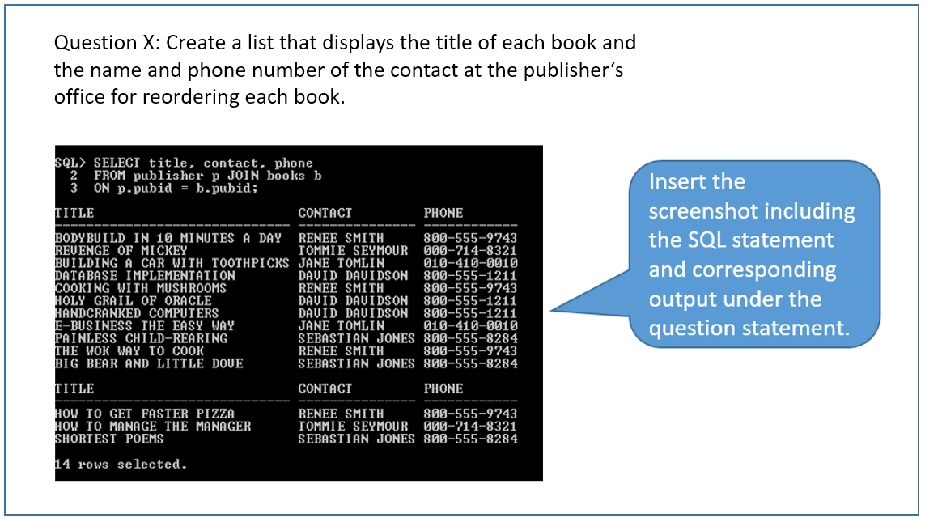

You are to use a sample database (JustLee Books) as the data source for some of the data query problems in this lab assignment. The SQL scripts for creating necessary tables and are provided in a separate file.

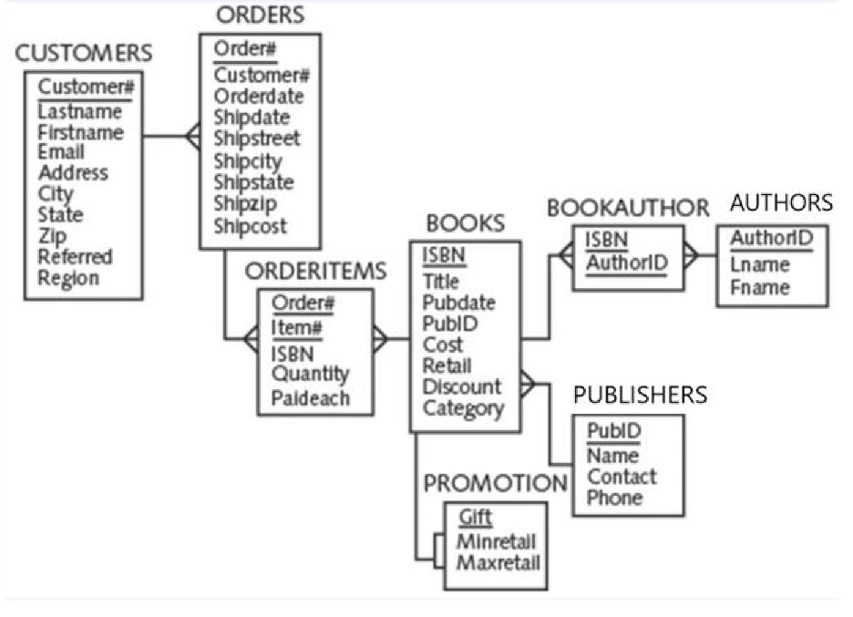

**PROBLEMS:**

1. Determine which orders were shipped on **the same state** as order 1014. (Also include the ship state and ship date in the query result.)

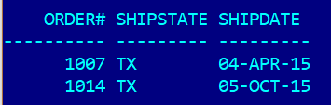

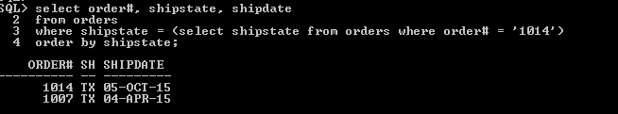

1. Find out the **most expensive book** sold by JustLee. (Show the title of the book, along with its retail price.)

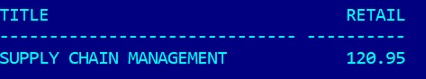

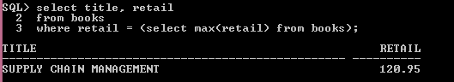

1. Find out the book that was **most recently published**. (List the book title and publication date.)

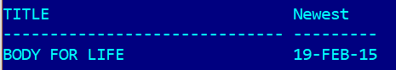

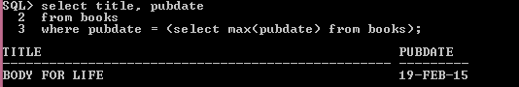ss

1. List the book title and retail price for all books with a retail price higher than the average retail price of all books sold by JustLee Books. Also include the average retail price of all books in the query result and sort the data by the retail price.

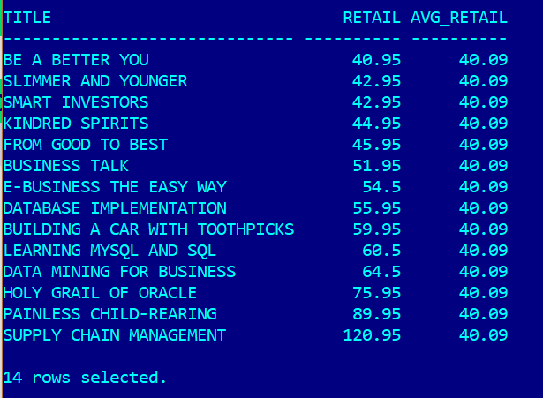

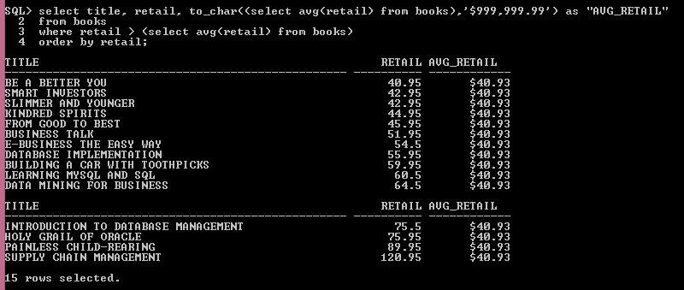

1. List the title of those books published by the publisher of the book “Big Bear and Little Dove” and those books that generate more than the average profit returned by all books sold by JustLee Books.

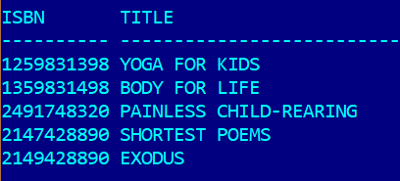

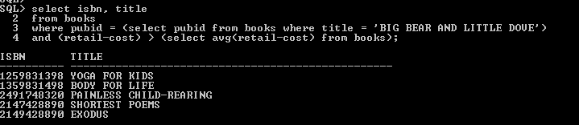

1. Find out those computer books that have a higher average profit than that of the book 'E-BUSINESS THE EASY WAY' (Note: profit = retail – cost).

